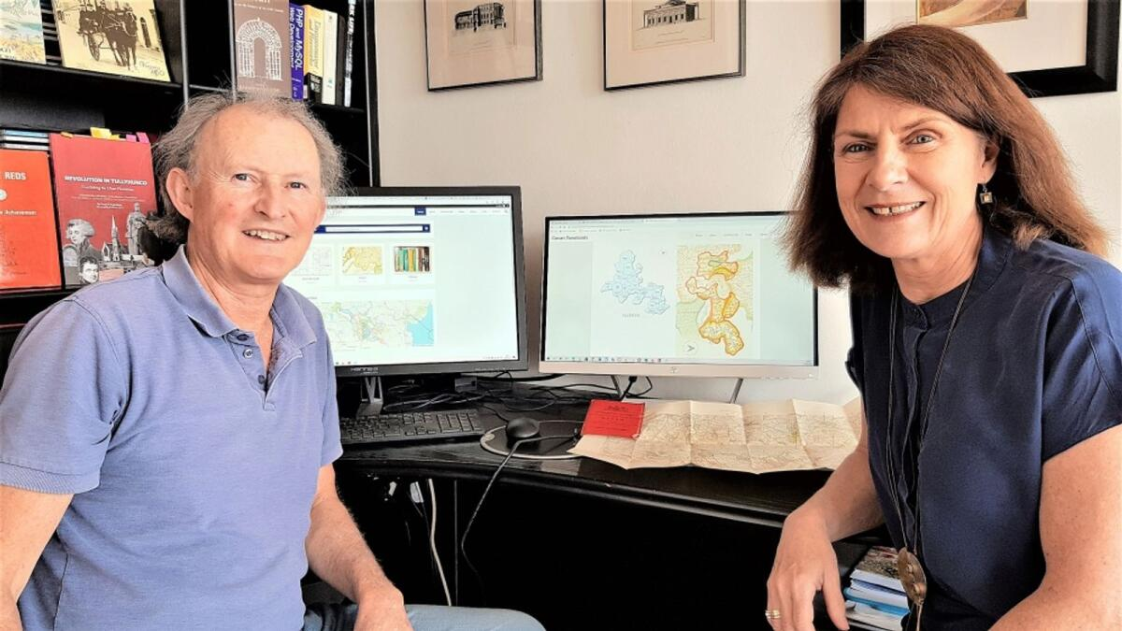

The hosts of the new cavantownlands.com website Michael McShane and his wife, Catherine Kerr with maps from the website on their screens in the background.

Website compiles data on 2,000 townlands in County Cavan
A new website featuring some 2,000 townlands in County Cavan is generating traffic from the four corners of the world by people traceing their ancestry and roots.
Cavantownlands.com continues to be developed by husband and wife duo, Michael McShane and Catherine Kerr. The couple live in Killiney in Dublin. Although not native to Cavan, Michael traced his ancestors back to the townland of Cloggy in the parish of Killeshandra and it was from that discovery, the website project spawned.
There are around 2,000 townlands in County Cavan - each one unique, according to Michael.
“We have created an individual page for each one. The new format is designed to bring together the historical data that we have uniquely researched along with the more generally available data, which we have edited and improved on in terms of access and quality,” he said.The website is already proving most popular in Ireland with 44% of the traffic domestic.
This is followed by the UK and USA on 20% each; while Canada and Australia are currently clocking up a five per cent share each of visitors to the site.
An architect by profession, Michael explained: “What started in 2009 as research into my family history has since developed into a passionate interest in historical sources for County Cavan. I now want to share my findings with others, who are keen to trace their Cavan ancestors and delve further into the history of Breifne.”
Wife Catherine, meanwhile, brings her experience as a data scientist to compiling and presenting the data into an easily accessible layout.
Search by townland
A search by townland will produce the following results in one location: A location map and basic townland information together with specific articles relevant to the townland where available.
For example, you will find the 1609 Bodley plantation map analysis for the townlands of the parishes of Kildallan, Killeshandra and Scrabby/Gowna. Some 137 townlands have been identified and classified.
Web users can find out what your townland was called in 1609 and who the land was granted to under the Plantation of Ulster. The name of the newly created estate, or proportion, can be found and the original maps can be viewed.
The 1652 Commonwealth survey data and maps for all parishes is worth exploring. After the quashing of the 1641 rebellion, the lands were regranted by Cromwell and the new proprietor name for each townland is provided, along with estate maps.
There is a further facility to check out the 1830 Tithe Applotment records for 35 of the 36 civil parishes. This has been re-indexed, corrected and presented in searchable tabulated form for ease of access. Tenant names are provided in this record of church tax applied to the tenant farmers.
Also of great interest is the 1836 Name Book records for the townlands of nine parishes first published in The Heart of Breifne 1979-1987. The nine parishes covered are - Bailieborough, Castlerahan, Crosserlough, Denn, Killinkere, Knockbride, Lavey, Munterconnaught and Shercock.
The 1841 Census of Killashendra is also included and is a cross-checked, corrected and fully searchable data set. This a unique record of all inhabitants - their name, age, occupation, educational and marriage status and more.
Featured too is the 1865 Griffith’s valuation records, which covers the entire of County Cavan. Tenant names are provided.
All townland records included, have been referenced to their official Logainm identifier (Logainm.ie is the official database of Irish placenames).
“We have also included an extensive library of maps and books, which are specific to County Cavan and this reference set is being enlarged on an on-going basis. The full version of a number of books and articles can be read here,” added Michael.
The couple are planning to upload more unique records and articles to the site.
“We are constantly seeking further historical information and any contributions including articles, books, photographs, maps etc are greatly appreciated and all contributors will be fully credited,” says Michael.
If you have any information or records, family histories, photographs and maps, that could further enhance the website, click on the contact page. Michael would be delighted to hear from you and is also more than happy to answer questions.
Check out cavantownlands.com

